FUNCTION BLOCK TYPE: EVENTS

A function block in IEC61499 can be an active or a passive element. A passive element waits for a event to trigger its functionality while an active element is time dependent. As we are migrating from the IEC61131-3 standards to IEC61499 standard, it has become a necessity to have total control over the events in the applications.The “events” type function blocks facilitate the manipulation of various events and process them as per our requirements.

WORKING OF EACH EVENT FUNCTION BLOCK

- E-CTD
- E-CTU
- E-CTUD
- E-CYCLE
- E-D_FF
- E-DELAY
- E-DEMUX-2
- E-FTRIG
- E-LDU *
- E-MERGE
- E-MUX-2
- E-PERMIT
- E-R-TRIG
- E-R-DELAY*
- E_REND
- E_RS
- E_R_TIMEOUT *
- E-SELECT
- E-SPLIT
- E-SR*
- E-SWITCH
- E_TIMEOUT*

E-CTD :
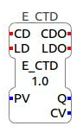
This event type function block is basically a down counter which counts down whenever CD is triggered starting from the preset value (PV). First to initialise we need to trigger the Load event (LD).This will set the Count Value(CV) to PV. Now triggering CD event will make the counter count down from the PV value. For subsequent triggers of CD the CV value becomes 1 value less.

Q becomes true when CV<=0.
CDO event is triggered when CD event is triggered.
LDO event is triggered when LD event is triggered.
PV value can be set using UINT#value.
It can count upto 0.

Ex. Let us Load the PV value of 50 to CV and subsequently trigger the CD event.
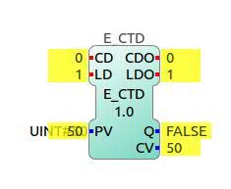
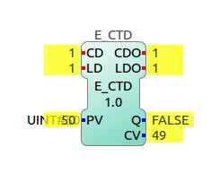
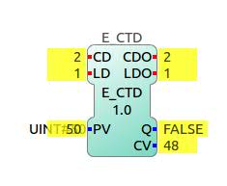

LD is triggered. CD is triggered. CD is again triggered

E-CTU:
This event type function block is basically an up counter which counts up whenever CU is triggered starting from 0. Triggering the Reset(R) event resets the count Value (CV) to zero. For subsequent triggers of CD the CV value becomes 1 value more.
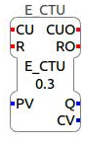
Q becomes true when CV>=PV.
CDO event is triggered when CD event is triggered.
RO event is triggered when R event is triggered.
PV value can be set using UINT#value.

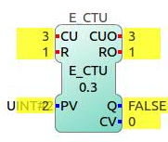
Ex.
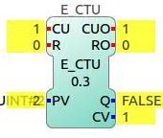
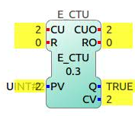
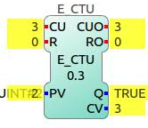

CU is triggered once CU is triggered twice CU is triggered thrice R is triggered

E-CTUD:
This event type function block is basically an up down counter which is capable of counting up as well as down depending upon the event triggered.It counts down whenever CD is triggered and counts up whenever CU is triggered.Triggering R will reset the CV to 0. Triggering LD will set the CV to PV.
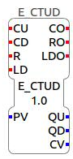
QD becomes true when CV<=0.
QU becomes true when CV>=PV
CO event is triggered when CU or CD event is triggered.
LDO event is triggered when LD event is triggered.
RO is triggered when R is triggered.
PV value can be set using UINT#value.
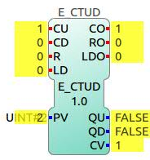
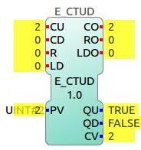
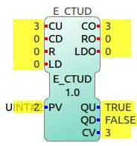

CU is triggered once. CU is triggered twice CU is triggered thrice

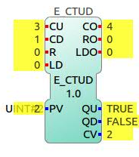
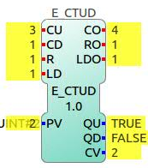
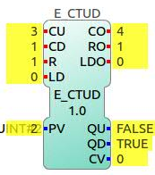

CD is triggered R is triggered LD is triggered

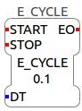
E-CYCLE:
E-CYCLE is an event type function block that is capable of triggering output event EO at intervals of time DT once the START is triggered. This block stops triggering EO when STOP is triggered.
DT can be set using t#time. Ex: t#1000ms or t#2s.

E_D_FF
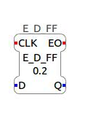
A D_FF block basically works like a D Flipflop. Whenever the Clock is triggered the Input Data D is sent to Output data Q. Output event EO is trigered only when there is a change in the Output Data from TRUE to FALSE or vice versa.

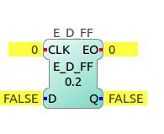
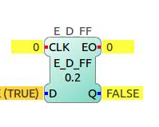
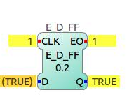

Initial state. D is given TRUE value clock is triggered

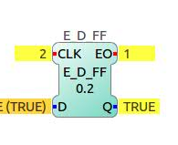
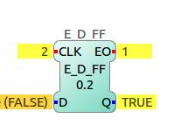
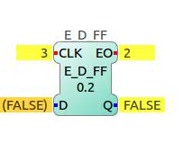

clock is triggered again D is given FALSE value clock is triggered

E_DELAY:
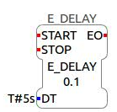
E_DELAY is a function block that triggers the output event after a specified time after the START event is triggered. DT can be set using T#time. Ex. T#5s. In this example if the START eent is triggered at t=0s then the EO will be trigered at t=5s.

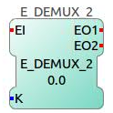
E_DEMUX2
As the name suggests this function block behaves like a demux. K can be assumed to be the selectline which can take UINT value 0 or 1. According to value of K EO1 or EO2 is triggered.
If K=0; EO1 is triggered when EI is triggered.
If K=1; EO2 is triggered when EI is triggered.
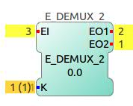
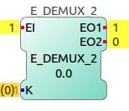
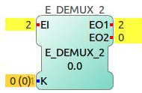

K=0; clock triggered K=0; again clock triggered K=1; clock triggered

E_F_TRIG:
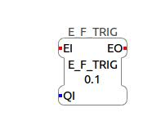
This function block triggers an output event only when it detetects a falling edge in data i.e input event being continuously triggered, output event will be triggered only when QI changes from TRUE to FALSE.
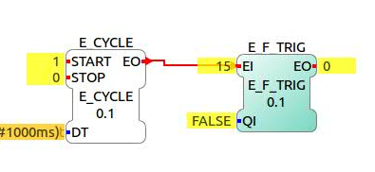
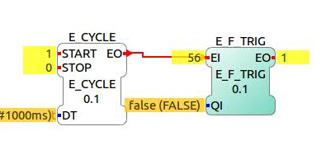

QI=FALSE

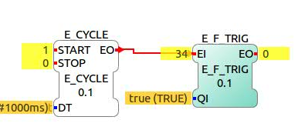

QI is made TRUE

QI is made false; EO detects falling edge and gets triggered.

E_LDU: (TO DO)

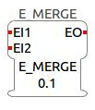
E_MERGE:
This function block essentially works like an OR gate of events.If either of the input events is triggered, the output event is triggered.

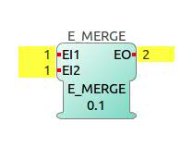
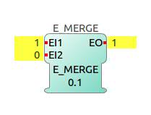

EI1 is triggered EI2 is triggered

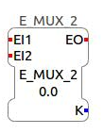
E_MUX_2:
Output event EO is triggered when either
of the two input events EI1 or EI2 is triggered. The output data K gives the input event number that is selected i.e last triggered.
If EI1 is triggered, K=0
If EI2 is triggered, K=1
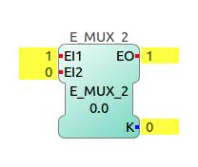
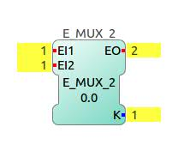

EI1 is triggered EI2 is triggered

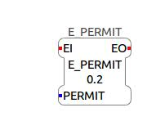
E_PERMIT:
This function block acts like a converter from data to event. The input event is passed as output event only when the PERMIT is TRUE otherwise if the PERMIT is FALSE, then the output event is not triggered even when the input event has been triggered.

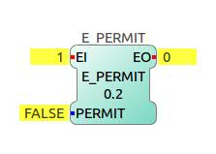
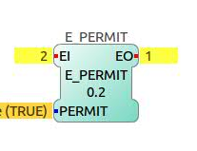

PERMIT=FALSE; EI triggered PERMIT=TRUE; EI triggered

E_R_TRIG:
This function block triggers an output event only when it detetects a rising edge in data i.e input event being continuously triggered, output event will be triggered only when QI changes from FALSE to TRUE.
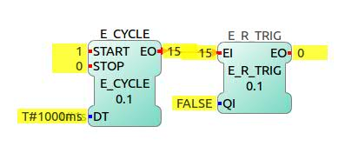

QI=FALSE

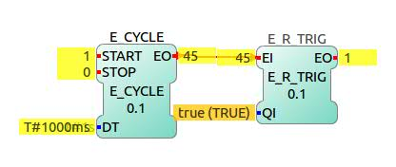

QI is made TRUE; EO gets triggered.
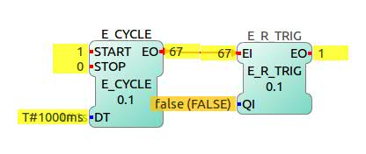

QI is made FALSE;
EO is not triggered.

E_R_DELAY (to do)
(*exactly same as E_DELAY*)
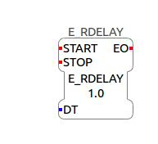
E_DELAY is a function block that triggers the output event after a specified time after the START event is triggered. DT can be set using T#time. Ex. T#5s. In this example if the START eent is triggered at t=0s then the EO will be trigered at t=5s.

E_REND:
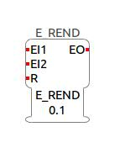
This function block has its functionality like an AND gate.The output event EO is triggered only when both EI1 and EI2 are triggered. If either of the input events is not triggered then the output event is not triggered.
After triggering one input event if reset is triggered then it resets the events and now if the other event is triggered, the output event wont be triggered.

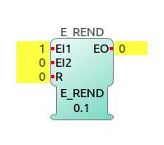
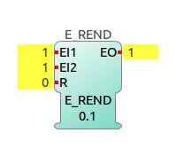

EI1 is triggered EI2 is triggered

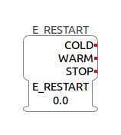
E_RESTART:
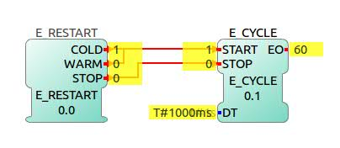
This function block takes in no input event but is resposible for producing events. This is usually used for starting and stopping of applications.On deployment of the application, the cold start occurs automatically. The subsequent starts are warm starts. Stop event intends to stop the application.

Application is deployed
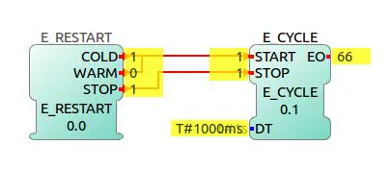

STOP is triggered

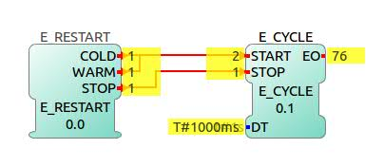

Warm start is triggered.

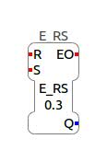
E_RS:
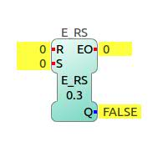
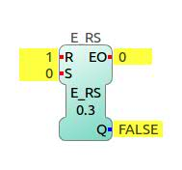
This function block acts like a RS flipflop. The output Data Q is set to 1 when S event is triggered and is reset to 0 when R event is triggered. The output event is triggered only when the output data changes from TRUE to FALSE or vice versa.
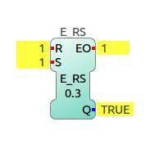

Initial state R is triggered S is triggered

E_R_TIMEOUT: (to do)

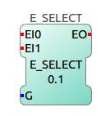
E_SELECT:
This function block allows to select the input event depending on the input data.Only triggering the selected input event will trigger the output event.
If G= FALSE; EI1 is selected.
If G=TRUE; EI2 is selected.
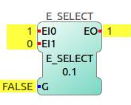
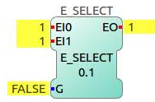

G=FALSE; EI1 triggered G=FALSE; EI2 triggered
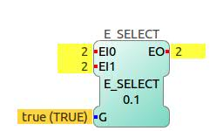

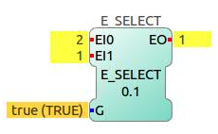

G=TRUE; EI1 triggered G=TRUE; EI2 triggered

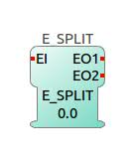
E_SPLIT:
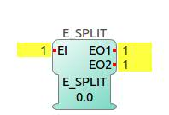
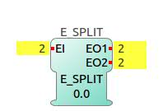
This function block takes in one input event and splits it into two output event. When the input event EI is triggered, both EO1 and EO2 will be triggered.

EI is triggered EI is triggered again

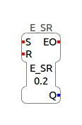
E_SR:
This function block acts like a SR flipflop. The output Data Q is set to 1 when S event is triggered and is reset to 0 when R event is triggered. The output event is triggered only when the output data changes from TRUE to FALSE or vice versa.

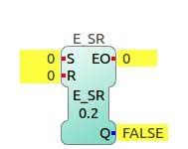
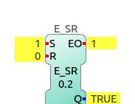
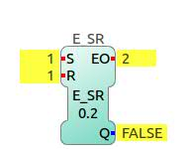

Initial state S is triggered R is triggered

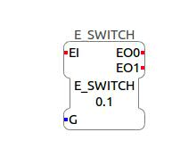
E_SWITCH:
This function block controls the selection of output event using a boolean data input. When input event is triggered, the output event to be triggered is decided by the boolean data.
If G=FALSE; EO1 is triggered;
If G=TRUE; EO2 is triggered.

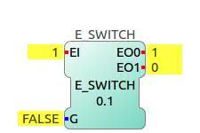
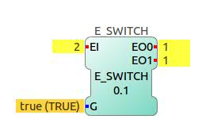

G=FALSE; EI triggered G= TRUE; EI triggered

E_TIMEOUT:(to do)

FBRT TYPE: HMI FUNCTION BLOCKS:

The HMI function blocks under the FBRT type provides us with an interface to give various types of input and outputs from a FBRT window.The user can be given control of the application using these blocks. The user can also get visual outputs on the window using the output blocks. The various types of function blocks along with their functions are elaborated below.

HMI FUNCTION BLOCKS:

- CHOICE_TABLE
- COLOR_HUE
- COLOR_SAT
- CONSOLE *
- CTU_OUT
- DIAG_LOG
- FB_BAR
- FB_LABEL
- FB_LEDS
- FB_SLIDER
- FB_TABLE
- IN_ANY
- IN_ARRAY
- IN_BOOL
- IN_CHOICE
- IN_COLOR
- IN_ENUM*
- IN_ENM_CTL*
- IN_EVENT
- IN_MATRIX*
- IN_TEXT
- IN_TEXT_S
- OUT_ANY
- OUT_ARRAY
- OUT_BOOL
- OUT_COLOR
- OUT_EVENT
- OUT_TEXT
- OUT_TEXT_S
- RADIO_BOOL
- STRIP_3
- STRIP_4
- TESTER *

CHOICE_TABLE
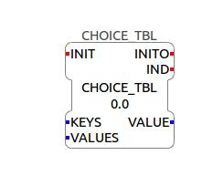
This function block allows to create an interface for the user in which he can choose a particular key from a drop box of choices.
The programmer writes the name of the keys separated by a comma in the KEYS.
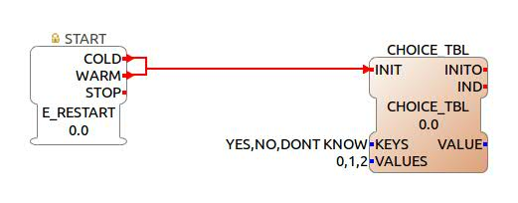
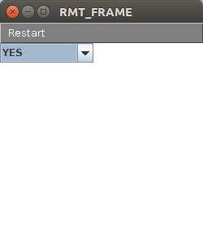
The values corresponding to each key is to be written at VALUES separated by commas. Output VALUE gives the value corresponding to the selected key.

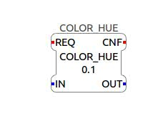
COLOR_HUE

This function block takes a color as an input and gives out its hue value as output.Input color can be given from IN_COLOR function block that will be discussed later.
Output is of real data type.

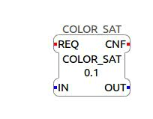
COLOR_SAT

This function block takes a color as an input and gives out its saturation value as output.Input color can be given from IN_COLOR function block that will be discussed later.
Output is of real data type.

CONSOLE
(TO DO)

CTU_OUT:

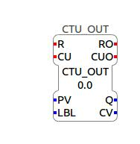
This function block is an up counter whose counter value is displayed in the FBRT window.R event needs to be triggered for initialisation and resetting of the function block.
CU event needs to be triggered to count up. PV is the preset value. LBL is the output name you wish to see on the FBRT window.CV value is displayed in the FBRT window.

DIAG_LOG
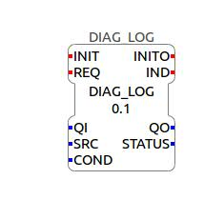
This function block maintains a record of the exact date and time at which a particular event was triggered. Whenever REQ is triggered, an event gets logged into the table that is displayed in the FBRT window. COND is the condition satisfied when the event was triggered.SRC is the source from which the event has been logged.

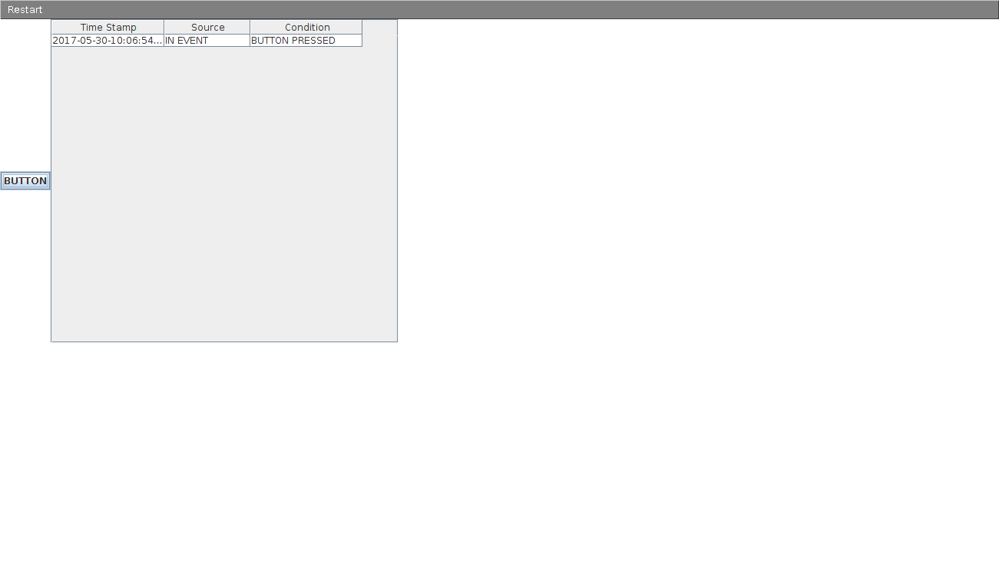
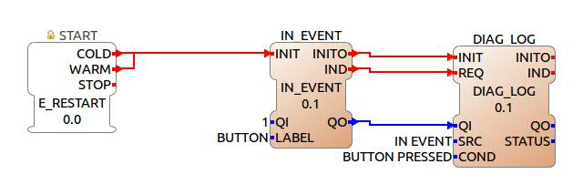

FB_BAR:
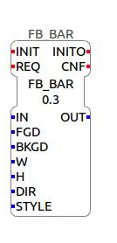
It is a function block that takes in an UINT value and scales a given dimension of block from 0% to 100% and shows the position of the input in that block. The background with a background color BKGD gets filled with a bar of color FGD. The width and height of the block can be specified in W and H. The direction in which the block should be filled is specified in DIR.
The STYLE specifies two types of showing the position.
- Bar- filling of the block using one color on another color.
- Slider- A pointer sliding across the block showing the position.
OUT gives the displayed value in UINT.

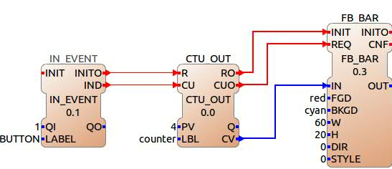

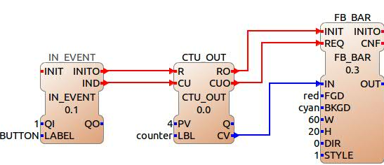

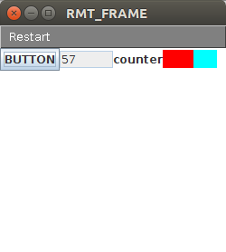
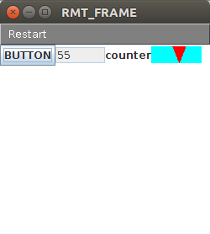

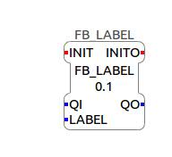
FB_LABEL
This function block is used to display any text on the FBRT window. Usually this block is used to label a particular output . Label is available in most of the input output blocks but sme blocks are devoid of this. In order to make the app user friendly LABEL block is used to make it informative.
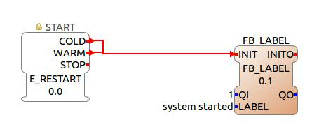

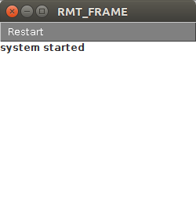

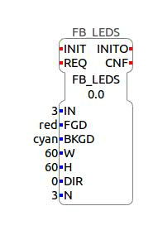
FB_LEDS:
This function block is capable of displaying binary numbers using LEDs. A block of a specified width and height is divided into N number slots. This block can display 2^N bits. So the IN must be less than 2^N. The FGD and BKGD are the colors of the led and the background respectively. W and H specifies the dimensions of the block..
DIR specifies the LSB and MSB of the block.
- 0 means left most is the LSB
- 1 means top most is the LSB
- 2 means right most is the LSB
- 3 means bottom most is the LSB
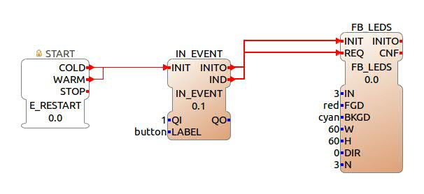
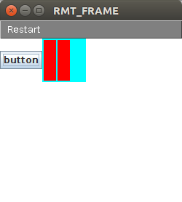

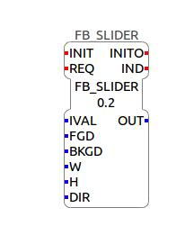
FB_SLIDER:
This function block gives the user the facility of sliding the slider in the FBRT window and give an corresponding UINT input to the subsequent blocks of the application. IVAL is the initial position of the slider.
FGD and BKGD are the forefround and background color respectively. W and H specifies the dimensions of the slider box . DIR is the direction of the slider movement.
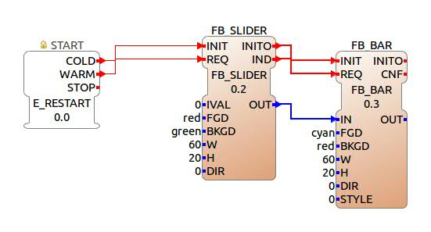
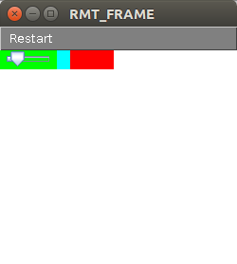
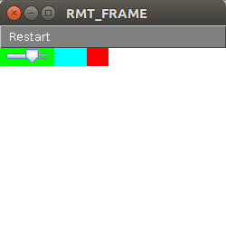

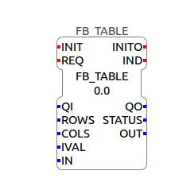
FB_TABLE:

IN_ANY & OUT_ANY:
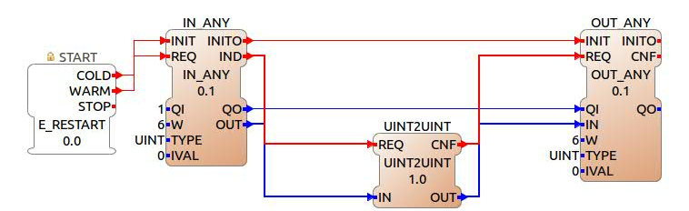
These two blocks are used to take input of any data type in the FBRT window (IN_ANY) and give an output of any data type in the FBRT window (OUT_ANY). This has been explained using these blocks with an example. The number entered in the input textfield is replicated in the output textfield in the FBRT window in this example.
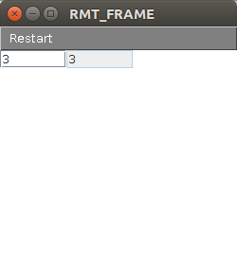
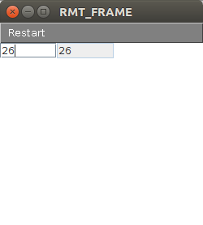

IN_ARRAY AND OUT_ARRAY

These two function blocks are capable of taking an array as an input from the FBRT window (IN_ARRAY) and give an array as an output on the window(OUT_ARRAY). W specifies the width of the text field. N specifies the number of elements in the array. Type is the data type of array elements. IVAL is the initial value of array elements. The elements in the array needs to be entered within square brackets separated by commas.
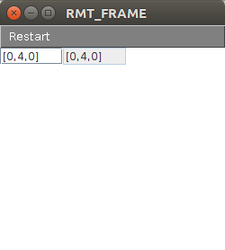
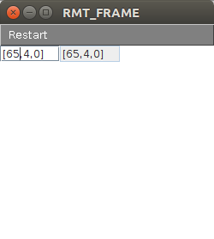
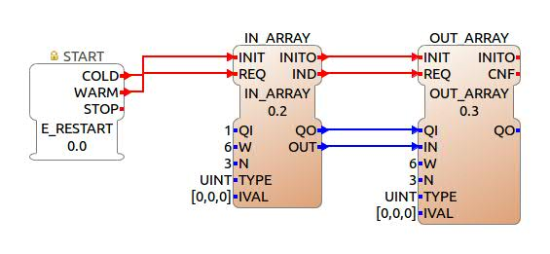

IN_BOOL & OUT_BOOL:
Using these function blocks one can take boolean input from the FBRT window(IN_BOOL) and also give an visual boolean output (OUT_BOOL).
In the IN_BOOL block
- IND gives the indication that the checkbox has been checked.
- OUT gives the output value either 0 or 1.
- IN is the initial value.
In the OUT_BOOL block
- IN is the input value to be displayed.
- C0 is the color to be displayed when IN=0.
- C1 is the color to be displayed when IN=1.
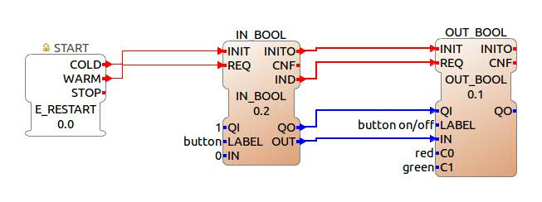
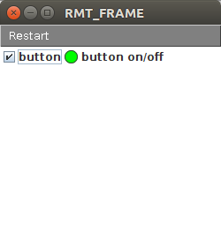
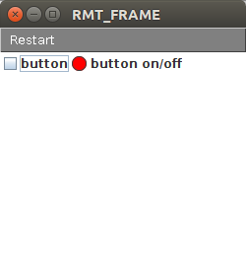

IN_CHOICE:
This function block allows the user to choose an option from a drop box menu of choises as defined at the backend. In the CHOICES we need to write the required choices we need in the drop box separated by commas. OUT gives the selected choice. I gives the index of the selected choice.

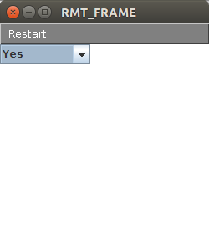
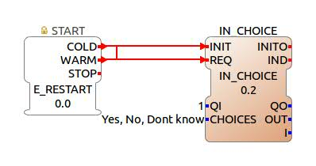

IN_COLOR & OUT_COLOR:
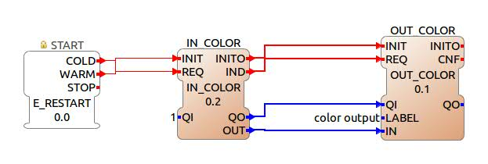
These function blocks take an input of a color choosing one from the drop box ( IN_COLOR) and show the color that has been given as an input to them (OUT_COLOR).
In IN_COLOR block OUT gives the name of the color chosen from the drop box. IND is the indication that a color has been chosen.
In OUT_COLOR block IN is the input color. LABEL is the name of the output we wish to show.
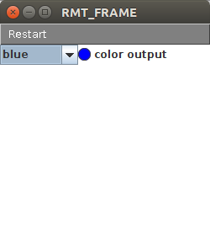
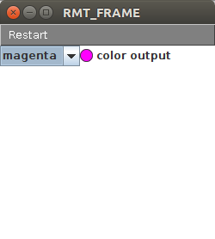

IN_ENUM (to do)
IN_ENUM_CTL(to do)

IN_EVENT and OUT_EVENT:

IN_EVENT is a function block that allows the user to trigger an event from the window. On pressing the button in the window, IND gets triggered. LABEL is the name of the event being triggered.
OUT_EVENT is a function block that flashes a color FLASH for a time DT under the name LABEL.
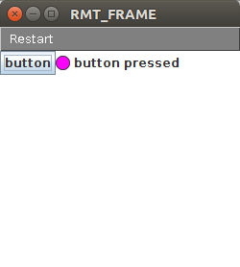
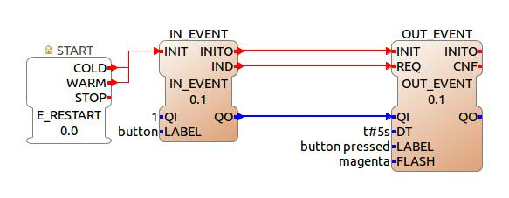

IN_TEXT & OUT_TEXT:
IN_TEXT fuction block is used to give a text input to the application. SIZE specifies the number of rows and columns of input text and IVAL is the initial wstring . OUT_TEXT is a function block used to give an text output that would be displayed on the FBRT screen.

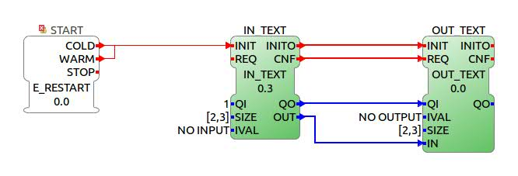
IN_TEXT_S & OUT_TEXT_S
These function blocks sunction exactly like the IN_TEXT and OUT_TEXT function blocks. They can take string values as input and output .
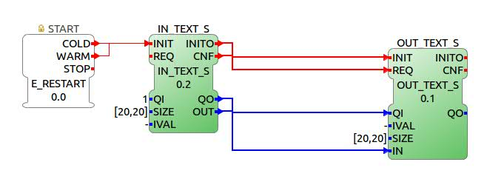

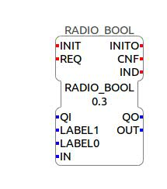
RADIO_BOOL:
This function block provides two options for the user which is specified in LABEL0 and LABEL1. If option in LABEL0 is chosen output is 0. If option in LABEL1 is selected output is 1.IN is the initial selection.

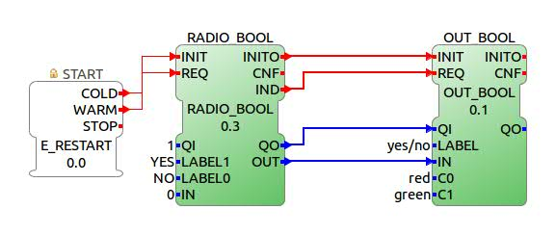
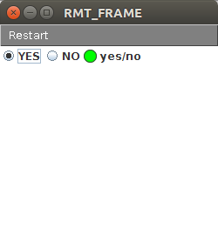
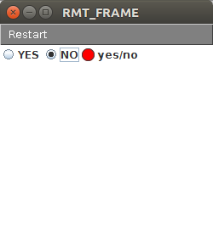

STRIP_3 AND STRIP_4:
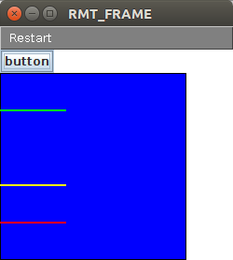
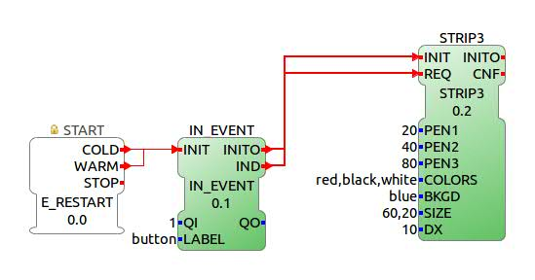
These two function blocks show 3 lines(STRIP_3) or 4 lines(STRIP_4) of specified colors on a specified background in the FBRT window. Whenever an event is triggered the length of these strips increase. The size of the block can also be specified.

